**Assignment 2:**

Read paper 6 and consider famous Bioinformatics software of your choice. How does it measure up to the recommendations? One to two pages is expected.

**Answer :**

The paper 6 presented here is: “Ten recommendations for creating usable bioinformatics command line software” by Torsten Seemann

The Bioinformatics command line software that I would like to use for this question is: “Bedtools”

The bedtools is a command line LINUX/UNIX bioinformatics tools that is used for performing wide range of genomic analyses. It is a fast , flexible toolset for performing genomic arithmetic. The bedtools is used for the tasks such as following:

1. Comparing intersections across many genomic intervals
2. Coverage analyses of targeted DNA capture.
3. Extracting promoter sequences from genome.
4. RNA seq coverage analysis

and many more. These tasks are performed *intersect*, *merge*, *count*, *complement*, and *shuffle* genomic intervals from multiple files in widely used genomic file formats such as BAM, BED, GFF/GTF, VCF.

Let us see now how this “Bedtools” command line tools measures up to the recommendations proposed by the above specified paper and will go through the ten recommendations one by one :

1. Print something if no parameters are supplied:

The Bedtools prints the help text when it is called out . the screenshot below is example of the output that comes from calling the tool :

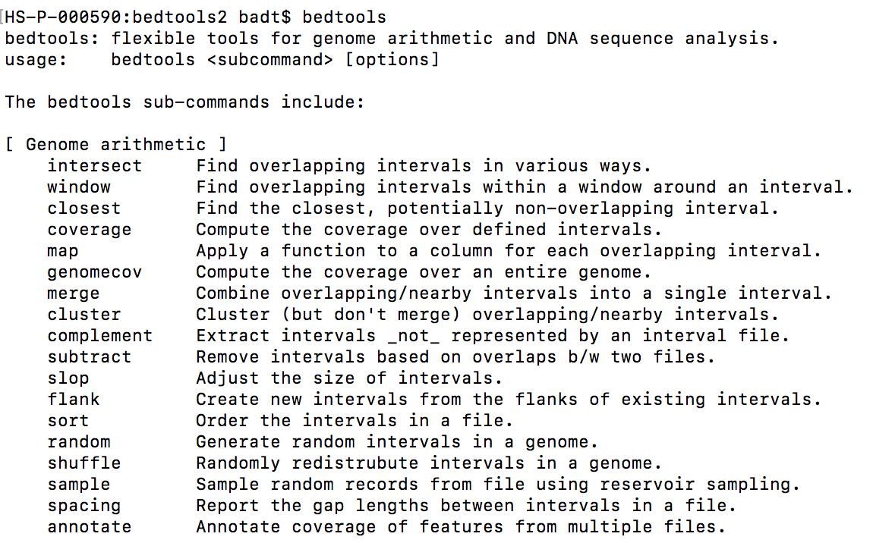

1. Always have a –h or –help switch

The Bedtools has a help switch which can be accessed by calling out:

bedtools –help

1. Have a –v or –version switch

The bedtools has a version switch that can be accessed by calling out : bedtools –version



1. Do not use stdout for messages and errors

The messages and errors are printed out for the progress and output information. And also has the option to check for errors as shown in the following figure:

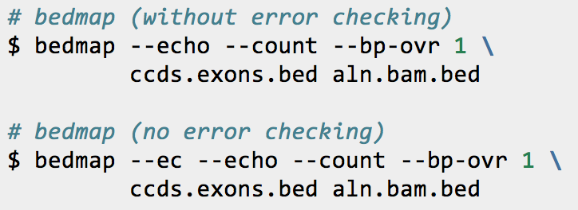

1. Always raise an error if something goes wrong:

The tool prompts when something goes wrong. For example it prompts if the given file is not in the required format such as BED files or Bam files

1. Validate your parameters

Since the Bedtools is an combination of multiple tools in itself , the parameters do vary for each case . and the help function and error prints drive you correctly for running the tool as per requirements.

1. Don’t hard code any paths:

Since this tool is installed in the HOME directory and can be called as a basic tool from any required path, the run of the tool is not hardcoded as well as the if we provide exact path specifications for the analysis files .

1. Don’t pollute the PATH

The installations of the Bedtools is quite simple and as it used make and we copy the PATH to the usr/bin using a single command, the original absolute path is never polluted with unnecessary things all sub tools are available under the name bedtools.

1. Check that dependencies are installed

The installation procedure is quite simple and if any of the required dependencies are not available the installation process doesn’t continue. You can see the installation procedure below :

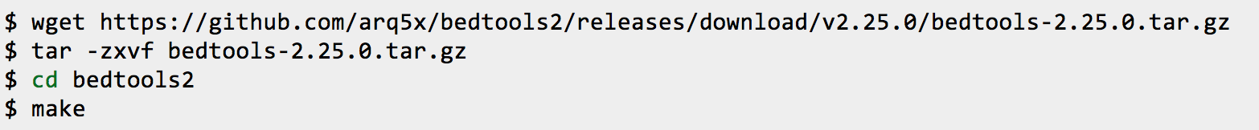

1. Don’t distribute bare JAR files:

Coming to final part , the code scripts are written in python and wrapper in the bash , so all the required files are compiled under single distribution.

Overall, the Bedtools command line tool measures and stands satisfactory & quite good in terms of recommendations of the paper stated above.